Results and discussion.
For the purpose of numerical simulation, we have taken Bi2Te3 as the semiconductor as both p and n type. The properties corresponding to p-type and n-type Bi2Te3 have been listed below in the following table.
Table 1: Properties of p-type and n-type Bi2Te3 semiconductor
Properties | p-type Bi2Te3 | n-type Bi2Te3
Seebeck coefficient (α) | -190 × 10⁻⁶ V/K | 190 × 10⁶ V/K
Thompson coefficient (μ) | -0.8 μV/K | 0.8 μV/K
Thermal conductivity (k) | 1.66 W/m.K | 1.66 W/m.K
Specific resistance (ρ) | 1.5 × 10⁻⁸ Ωm | 1.5 × 10⁻⁸ Ωm
Width (l) | 1.4 mm | 1.4 mm

Resistance in the external circuit (R_{L}) is taken in the range of 50 Ohms to 250 Ohms. Temperature at the hot side is varied in the range of 400 K to 600 K and the temperature at the cold side is take in the range of 313 K to 413 K. The other parameters required for numerical simulation have been listed below.
Table 2: Parameters taken in the numerical simulation
Thermal conductivity of ceramic plate (k_{ce}) | 230 W/m.K | Thermal conductivity of copper plate (k_{cu}) | 398 W/m.K
Thickness of the ceramic plate (l_{ce}) | 0.5 mm | Thickness of the copper plate (l_{cu}) | 3 mm
Gap between p-type and n-type legs (l_{g}) | 1.5 mm | Thickness of the semiconductor (l_{sc}) | 5 mm – 15 mm
No. of N-P pairs (N) | 100 - 200 | Specific Resistance of copper (ρ_{cu}) | 1.68 × 10⁻⁸ Ωm

- In the first parametric study, the load resistance in the external circuit has been varied from 50 Ohms to 250 Ohms and the corresponding variation in electrical power output and efficiency has been found out, which is shown below.
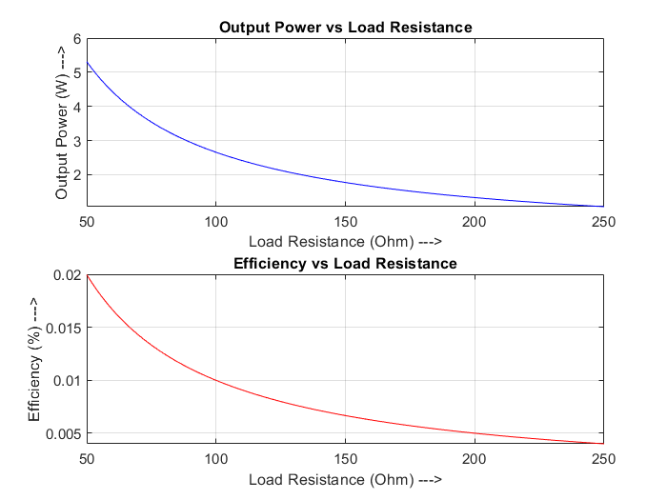
From Figure. () it can be seen that the output power and efficiency decrease exponentially with increase in load resistance in the external circuit. This happens because with in load resistance, current flowing through the circuit reduces, which causes output power to reduce and thus the efficiency of the TEG.

- Next, the hot side temperature has been varied from 400 K to 600 K and the corresponding variation in electrical power output and efficiency has been found out, which is shown below.
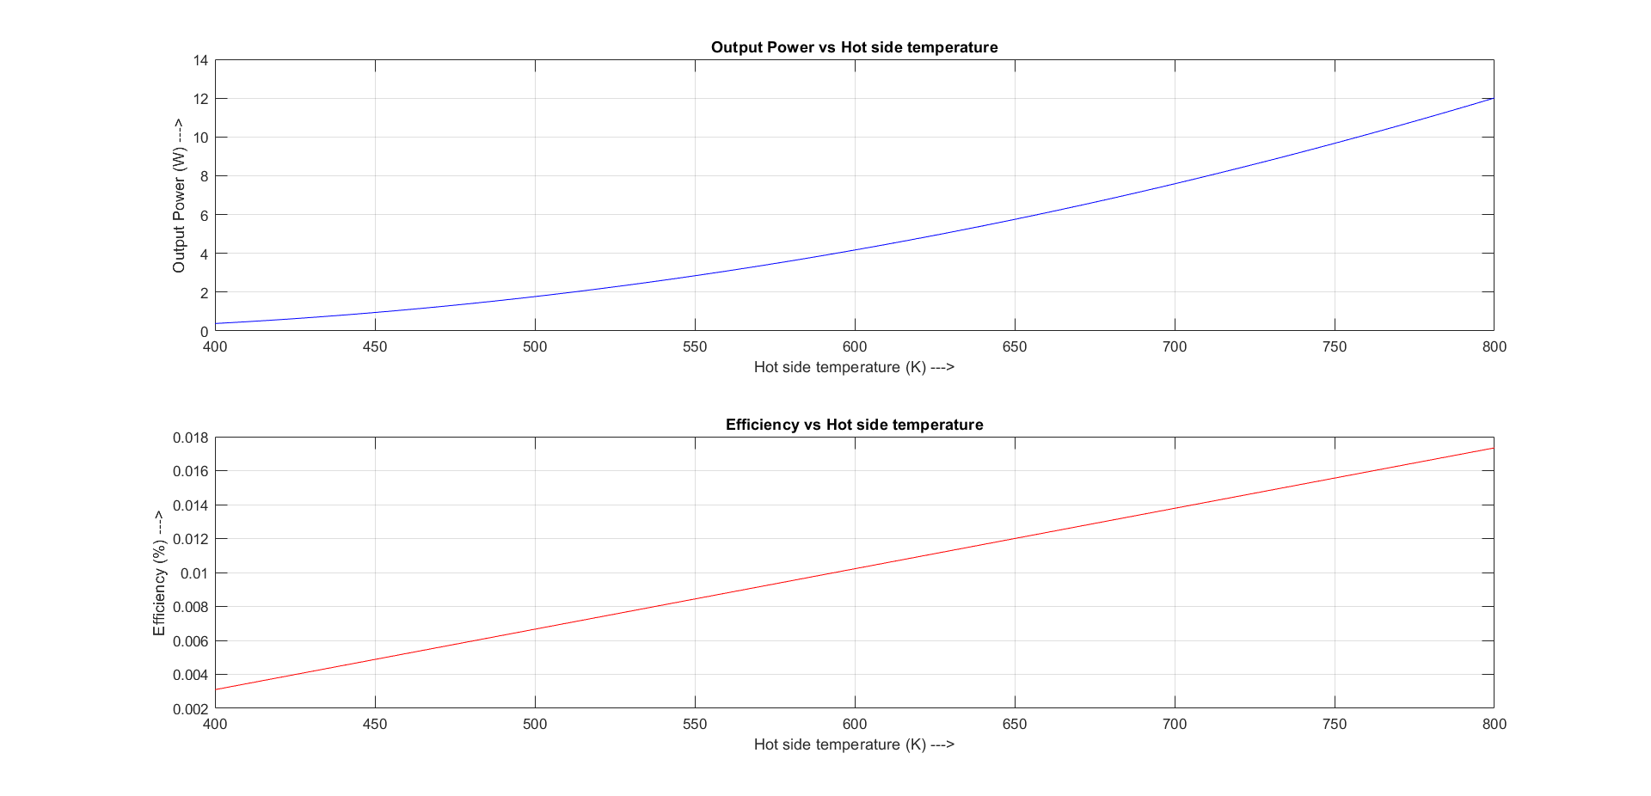
As can be seen from the diagram as the hot side temperature increases, total power output as well as efficiency increases. The main reason for that is, with increase in hot side temperature while keeping the cold side temperature constant, the heat influx increases, which increases Seebeck coefficient value, which in turn increases the current and thus the output power and efficiency.

- Now, the cold side temperature has been varied from 313 K to 413 K and the corresponding variation in electrical power output and efficiency has been plotted, which is depicted below.

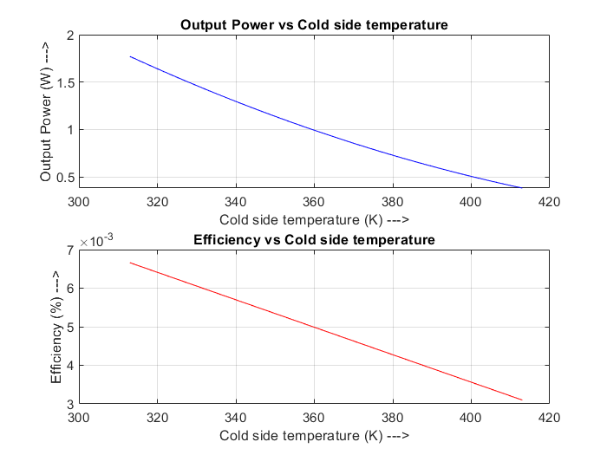
Now as the cold side temperature increases, the temperature difference between both ends of the thermoelectric generator decreases, which the potential difference developed between the both ends of the semiconductor, as result the output power decreases. Now, the heat influx also reduces with increase in temperature at the cold side of the TE module, but due to higher decrease in output power, the overall efficiency reduces.
- Next, the thickness of the semiconductor has been varied from 5 mm to 15 mm and the corresponding variation in electrical power output and efficiency has been plotted, which is shown below.
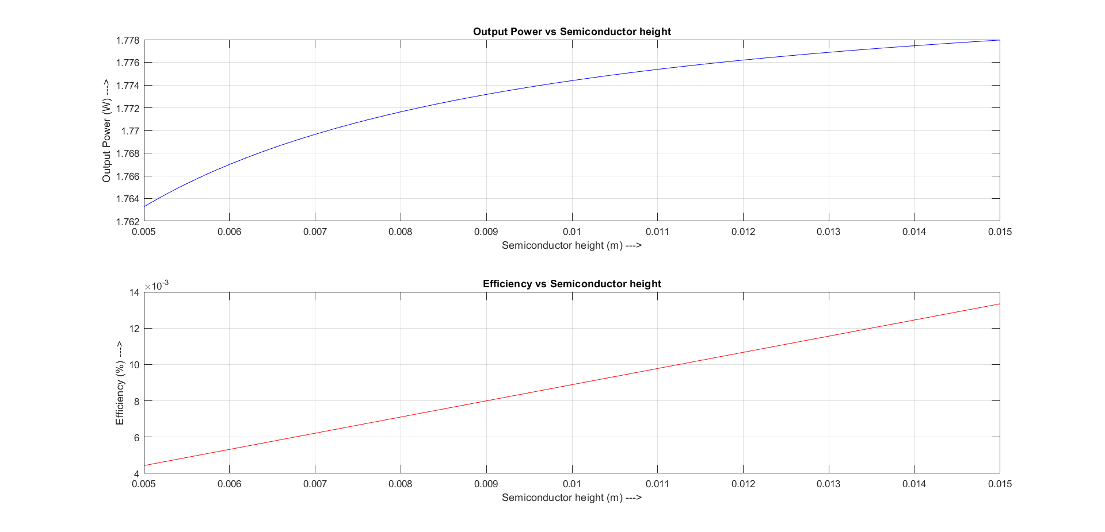
With increase in semiconductor thickness, overall power output and efficiency both is seen to be increasing. It may be due to the fact that with increase in semiconductor’s height, the overall number of charge carriers increases which results in a higher potential difference between the ends.

- Finally, the number of N-P pairs i.e. thermoelectric modules have been varied from 100 to 200 and the corresponding variation in the electrical output power and efficiency as obtained through the numerical simulation of the model have been plotted below.
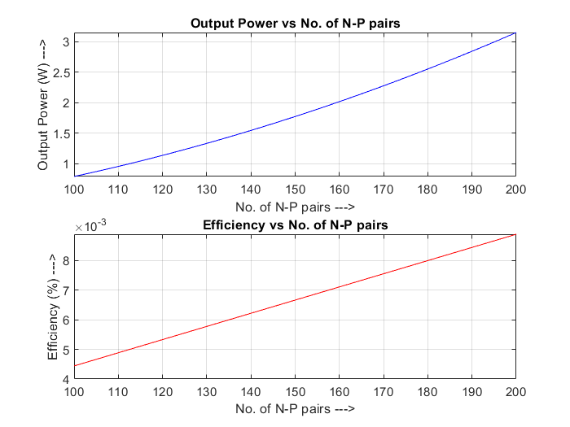
From the above plot, it can be seen that with increase in number of thermocouples, power output of the TEG increases, which is obvious as with n no. of thermocouples, power generated will be equal to the n times the power generated by a single thermocouple. Again with increase in thermocouples, heat influx increases but the increase in output power is more prominent as some of the heat that could be lost, can be regained by the close spacing of the thermocouples, which increases the efficiency.

